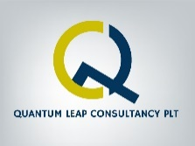

Zefer Hill Residence Condo, Jalan Pipit 4, Bandar Puchong Jaya, 47170 Puchong, Selangor.

Tel: 60123850657 Email: vasudevqlc@gmail.com

*Quantum Leap Consultancy PLT (LLP0003664LGN)*

**INTRODUCTION**

TITLE:  **MANAGING CHANGE – Mindset Rewiring**

1.RIVER Mindset



*The 5 Mindset, when rewired, unleashes greater potentials that not only guides the participants to adapt well to the current challenges, but to soar high in performance.*

3. SNAKE Mindset

2. TIGER Mindset





(It’s about tools, clarity and guidance on how to lead change, manage people & situations, and accelerate performance in the face of current challenges. They’ll be equipped with tools that will give greater empowerment in managing themselves, others, situations and performance)

5. HORSE Mindset

4. EAGLE Mindset





* + - * **PROGRAM DURATION:** 2 Days
      * **MAXIMUM PAX PER GROUP:** 24
      * **TARGETED AUDIENCE:** All levels
      * **METHODOLOGY:** Face To Face / Virtual

**SYNOPSIS**

This training program is about managing current work challenges in the company effectively and bringing out the highest potential that is within the individual and soar higher in their performance. Practicing the 5 mindsets given from the program enables the leaders to harmonize with the current reality in the company, Re-think & Re-invent themselves to fit into the current work demands.

Change is apparently inevitable in all organisations. Organisations have increased their demands on the employees due to greater competition and market demands. Based on the work of Peter Senge, the challenges that will be encountered by organisations in the next twenty years will be more complex and demanding. Employees competencies will be taxed to meet market demands. *Employees can expect the following challenges ahead of them:*

* Rising change turbulence causing rising stress
* Increasing internal competitiveness and disconnection with organisational goals.
* People working harder rather than wiser.
* In solving problems leaders will be engaged in great venture of exploration, risk, discovery, and change, without any comprehensive maps for guidance.
* Pressure to adopt sales and service culture for all job functions.
* Employees will be out of job if they don’t optimize their inner potential towards organisational growth.
* Demand to upgrade self-management skills in keeping abreast with market pressure.
* Meeting customer’s rising demands.

The approach undertaken in this workshop is based on our vast experience in the field of managing change and performance improvement. It is a very practical and a comprehensive concept that covers every aspect of achieving excellence in work performance.

Attitudinal change or self-motivation cannot be forced into someone. It can happen only through “Perspective-Shift” that creates higher motivation that leads to better performance.

**Perspective Shift**

**Higher Motivation**

**Better Performance**

**TRAINING OBJECTIVES**

1. Increased level of acceptance and adaptation to the new challenges
2. Shifting of mental model that is appropriate in handling the current change-adversities.
3. Sees the challenges as opportunities for further growth
4. Inspired to be a goal-oriented change driver
5. Tools to be a performer while facing challenges
6. Applying creativity and innovative thinking

**PROGRAM METHODOLOGY**

1. Interactive lecture
2. Case Study
3. Video
4. Interactive Discussions & Presentations
5. Mind Tools
6. Experiential Simulations
7. Puzzles and games

**COURSE OUTLINE**

**Day 1**

|  |  |  |
| --- | --- | --- |
|  | **TOPIC** | **LEARNING OBJECTIVE** |
| **9.00am** | * UNDERSTANDING CURRENT CHALLENGES IN THE COMPANY * 6R LEARNING PROCESS * SELF RENEWAL BEFORE RESULT RENEWAL * SELF BARRIERS | * Be aware of what’s happening around them in terms of challenges, expectations and market demands. * Applying RECEIVE, REFLECT, RELATE, REALIZE, RESPOND & REGULATE in the program and in their daily situations at work. * Able to detect the gap between state of the self and state of result and pursue profound change to improve desired results. * Identify personal weakness and set motivation for self-change. |
| **10.30am** | * TEABREAK |  |
| **10.45am** | * TRANSFORMATIONAL INFLUENCE * MANAGING CHANGE RESISTANCE – RCCA PHENOMENA | * Realize that one’s profound change comes from the Belief and Core-self shift, which are the change centers in the primary dimension. * Understand how the change resistance happens in the mind and how to take it to adaptation quickly. |
| **1.00pm** | * LUNCH |  |
| **2.00pm** | * RIVER Mindset * Art of Flowing * Adaptive skill | * Motivated to acquire the characteristics of a river that adjusts, adapts and flows with all the challenges in front of it * Know the method to harmonize with reality * Know the method to tune up to adapt |
| **3.40pm** | * TEABREAK |  |
| **4.00pm** | * TIGER Mindset * Reserve/Rethink/Reinvent | * Know the importance of pre-empting, reserving energy and preparing oneself to achieve high performance. * Know the importance of researching new ideas and innovate better ways of working |
| **5.00pm** | * END OF DAY 1 |  |

**Day 2**

|  |  |  |
| --- | --- | --- |
| **9.00am** | * SNAKE Mindset * Shredding old pains and comfort zones * Shredding paralyzing beliefs * Reprogramming empowering beliefs | * Learn the importance of forgetting old ways of working that’s not fitting in now. * Identify obsolete beliefs that’s paralyzing current performance * Learn Belief Reprograming technique |
| **10.30am** | TEABREAK |  |
| **10.50** | * EAGLE Mindset * Eye constantly focused on target * Ascend above all barriers * Glide higher when faced with a strong wind current * Land, nest and rest on higher ground * Even the might wings and exercise the mighty C.L.A.W.S. | * Motivated to acquire the characteristics of an Eagle in order to be a high performer. * Know how to set goals using the SMART principle and pursue them with determination * Learn techniques to manage negative thoughts, emotions, and beliefs. * Learn the importance of embracing work challenges and using them to evolve into a higher performer and a better human. * Understand and apply Chaos Theory and Kaizen mindset * Understand one’s higher and lower mind tendencies. * Learn techniques to operate from the higher mind always. * Motivated to live in higher paradigm from the best self always * Understand the need to balance performance with mental health. * Learn methods to sustain high performance and high mental peace. |
| **1.00pm** | LUNCH |  |
| **2.00pm** | * EXERCISING THE MIGHTY C.L.A.W.S. OF THE EAGLE * C – Creativity (Operating from Breakthrough Mentality) * L – Love for people and work * A – Appreciation & gratitude * W – Win for all Intention * S – Sincerity with Inner silence | * Learn methods to make the mind creative * Motivated to apply “Breakthrough” mindset. * Learn about the power of LOVE * Learn how to LOVE the people at work and work * Learn the importance of increasing personal energy through appreciation of all the good around one and gratitude to all the blessings * Learn about the power of aligning the intentions towards everyone’s wellbeing. * Learn about the importance of sincerity and its power when coupled with inner silence. |
| **3.30pm** | * TEABREAK |  |
| **3.50pm** | * HORSE Mindset * Action Oriented * Single minded tasking * ACTION PLAN | * Motivated to be action oriented than to be excuse oriented * Know the value of engaging on a task with one pointedness. * Undertake commitment towards applying all the things learnt with the determination to achieve high performance. |
| **5.00pm** | END OF PROGRAM |  |

**DURATION:**

* 2 Days (14 Hours)

**TARGETED AUDIENCE**

* Leaders

**TRAINING TYPE**

* Virtual

**MAIN TRAINER**

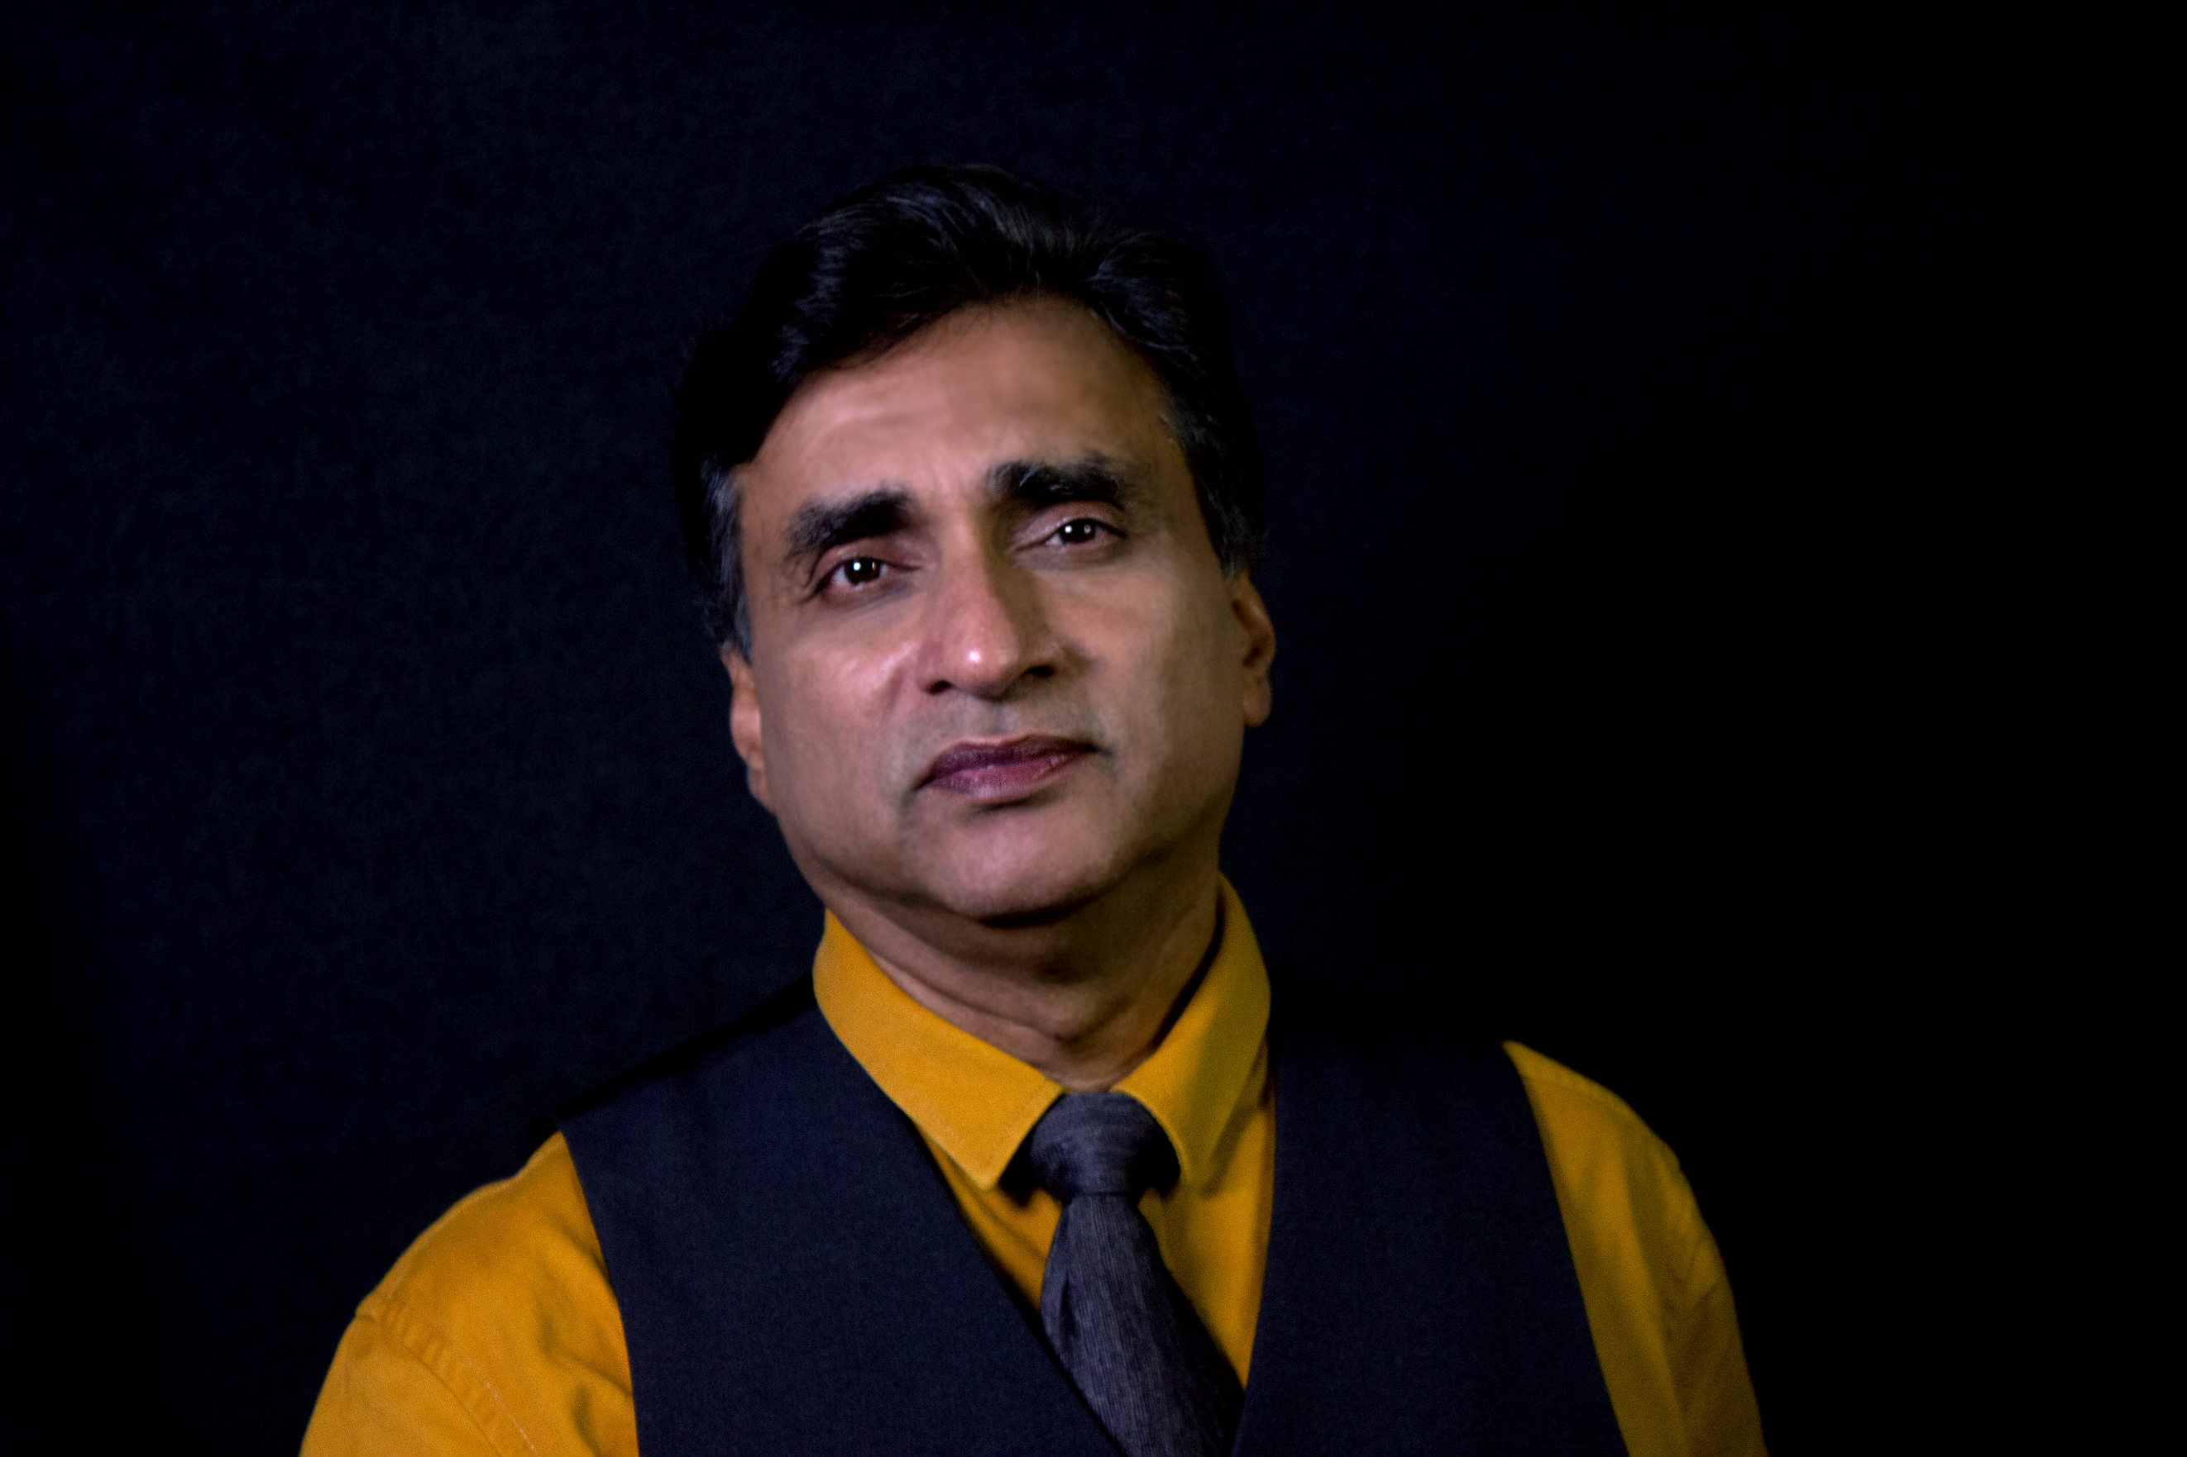

Vasu Thevan @ Vasudev

Trainer/Coach/Consultant

**QUALIFICATION & EXPERIENCE**

* Master’s Degree in Human Resource Training & Development
* Certified HRDF trainer
* Pioneer EQ Trainer
* Only CQ (Collaborative Intelligence) Trainer in Malaysia
* Author of around 20 manuals
* Author of “Collaborative Intelligence At Work” book (about to be released)
* 30 years of Training, Consulting & Coaching experience

**COACHING ENGAGEMENTS FOR**:

* GD Express
* Dagangnet
* A.P.S. Manja
* Almaa Malaysia
* Hawk group
* Triangle Worldwide

**FOUNDER OF:**

* “Science Of Achieving Results” (S.O.A.R) Coaching Model
* Law Of Attraction Tools & Therapy – 30 day audio-based course
* EQ Enhancement Tools
* “Collaborative Intelligence At Work” material
* Team Chemistry Rewiring Process
* 2P Paradigm (Peace & Performance material)
* P.A.J.E.R.O. Problem Solving Tool
* ELP (Experience Learning Process) training methodologies

**AREA OF SPECIALIZATION:**

*Critical Thinking Skills, Design Thinking, Problem Solving & Decision Making, Sales Empowerment, Supervisory & Managerial Development, Managing Change, Collaborative Intelligence (CQ)****,*** *Coaching & Mentoring, Performance Improvement, Creating & Customizing training modules & Consulting, People Management, Teambuilding, Change Psychology, Leadership, Performance Improvement, Customer Service, Managing By Values, Resolving Conflict, Communication, Confidence Development, Creativity Enhancement, EQ Enhancement, Personal Mastery, and Competency Based Management.*

**CONSULTING ENGAGEMENTS:**

Establishing “Customer Service Excellence” SOP for Dagangnet; CBM (Competency Based Management) at Epson Precision (Malaysia) Sdn. Bhd., ACTION values co-creation and implementation project for Safeguard Securicor, Sales Improvement project for Magnus Quest Sdn. Bhd., Sales Improvement project for Biotech Malaysia Sdn. Bhd., Strategic Management Project for the Sports & Youth Minister’s working group and currently steering Century Software Sdn. Bhd. into a customer centric organization – a nine months intervention covering the creation of Customer-centric behaviour dictionary, Culture change initiatives, Leadership Coaching & Problem-Solving Laboratory and Sales Improvement project for GlaxoSmithKline.

**CLIENTAL:**

*ASEAN Banking School (Post Graduate Training),* *Giant/Guardian/Carrefour (Supervisory & Managerial Development), YTY Group (Teambuilding), Segi University (Managing Stress), TAR University (Conflict & Time Management), Brickfields Asia College (Leadership), Wong & Partners (Leadership), GDex (Collaborative Intelligence, Managing Difficult customers, Sales Training & Coaching, Leadership training & Coaching),* *Dagangnet (Collaborative Intelligence, Stress Management, 6 Positive Thinking Skills, Change Driver Coaching & 3A Coaching), Maybank Assurance (Performance Acceleration), Ambank (Problem Solving & Decision Making), IBBM (Conflict management, Leadership), Bank Negara (Conflict Management & Leadership), AKPK (Counseling Training), SIDC of Securities Commission (Communication, EQ & Problem Solving Training); Telekom Malaysia (Customer Service); MINDEF (Collaborative Intelligence); Petronas INSTEP (Executive Development); Genting (Stress Management), MIDA (Leadership); Century Software (Customer Centric training & consulting); Kem. Pengajian Tinggi (Leadership); JVC (Change Management), Epson Precision (Competency Based Management training & consulting), GlaxoSmithKline (Sales & Motivation), MNI (Leadership & Performance), Prudential agencies (Sales & Motivation), Great Eastern agencies (Sales & Motivation), etc.*

**MEDIA APPEARANCE:**

Vasu has been frequently interviewed in the television on Values and EQ education, which was a live broadcast. He has continuously appeared in the press as the solution provider for some pressing issues at hand, aired live through Radio 6 and appeared in Astro for continuing episodes on Human Values Education. Vasu was also called to provide special lectures at University Malaya.